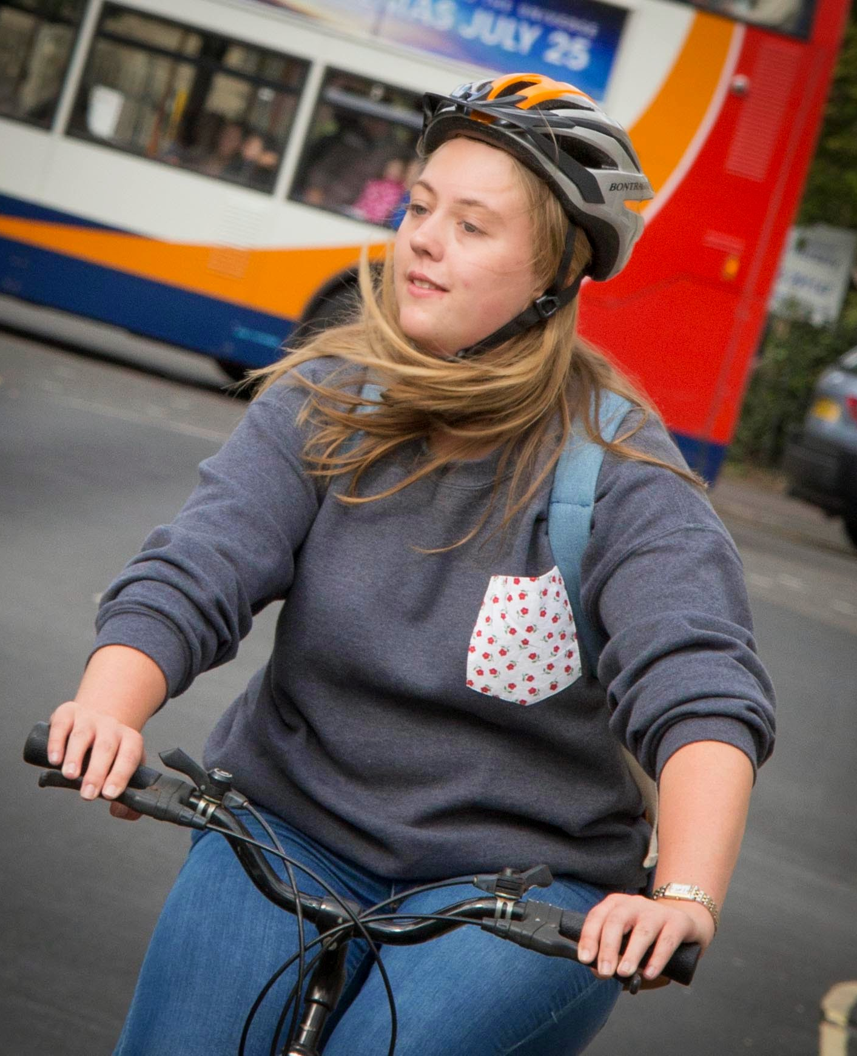
Enthusing More People to Cycle
Bikeability Level 3 Cycle Training Parental Information

Free




Bikeability is the government’s national cycle training programme. The scheme aims to inspire more children to cycle by equipping them with the skills and confidence to ride more.
Bikeability

All the training is delivered by Outspoken Training’s qualified and DBS checked Instructors.

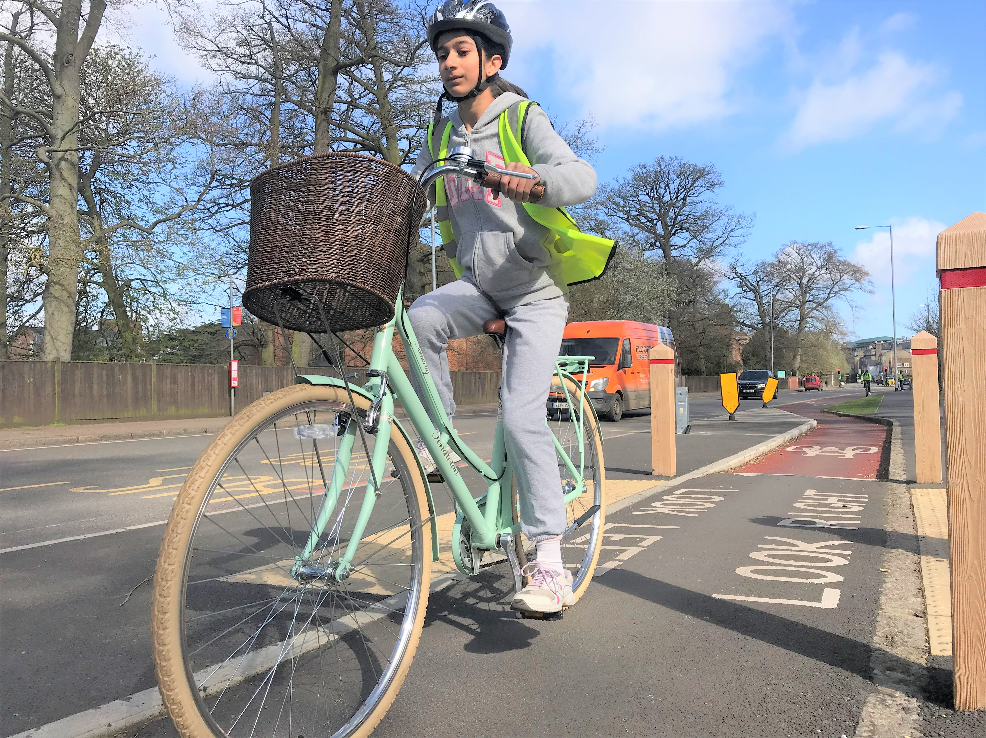

Bikeability Level 3 Course

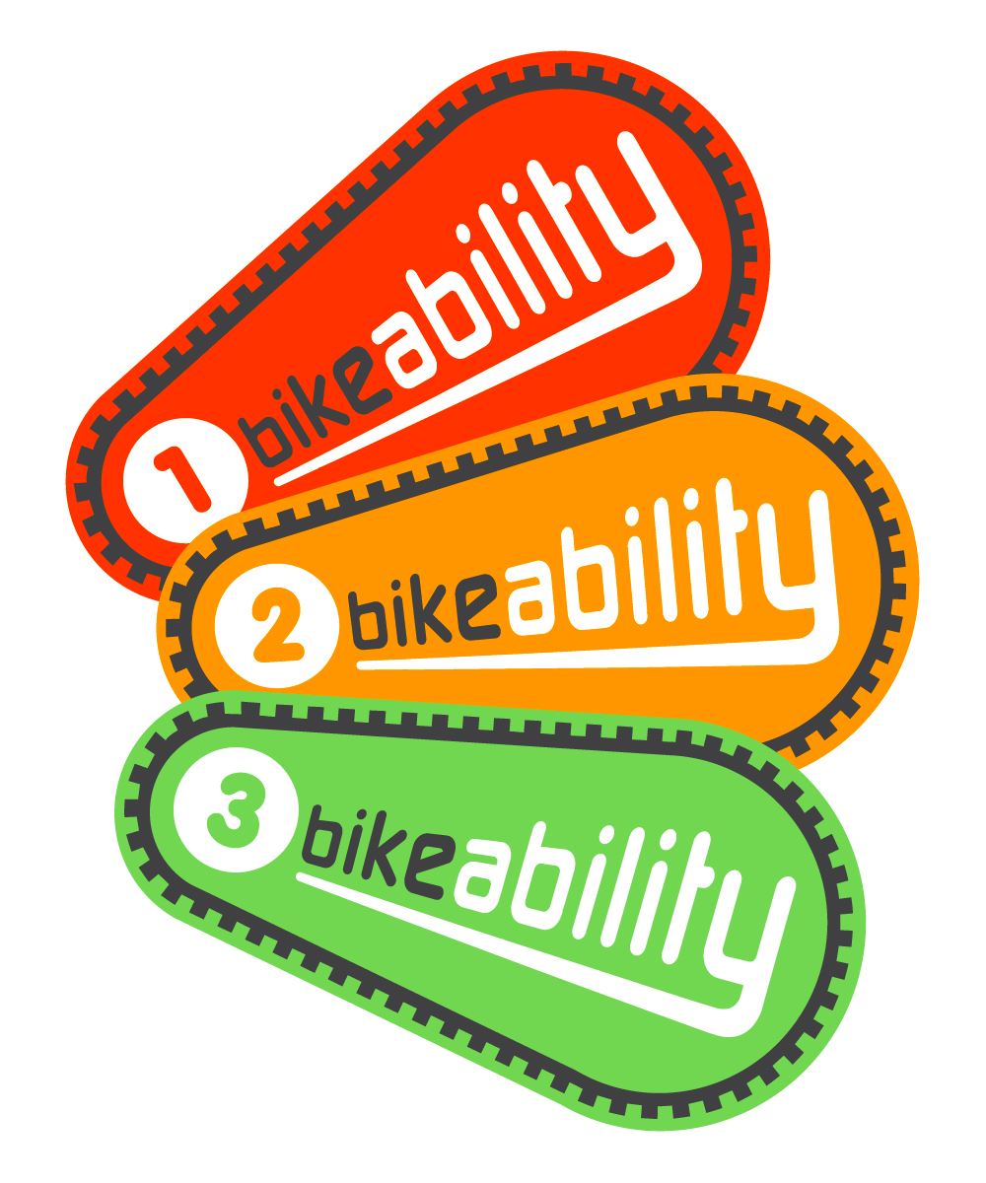
Has your child achieved Bikeability Level 1 & 2? If so, they have the opportunity to complete the Bikeability Award scheme by undertaking Level 3 training.

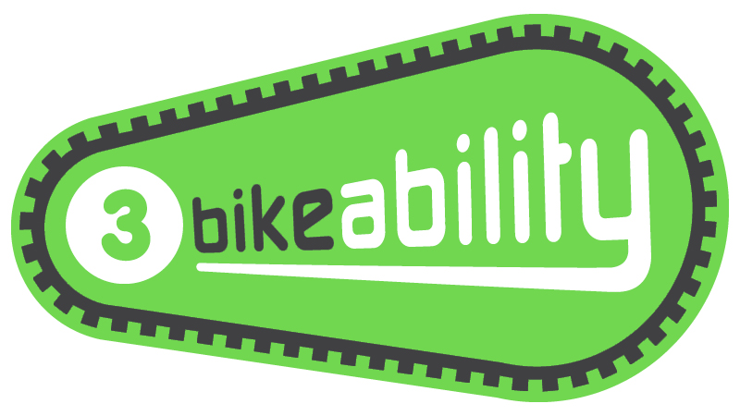
Level 3 equips riders with the skills to tackle more complex roads and traffic situations. Included is:

- Using the best riding position for any situation
- Riding alongside other cyclists
- Riding on my complex roads
- Negotiating more complex roads such as junctions controlled by traffic lights, multi-lane roads and cycle lanes
- Route planning
Date: Wednesday 16th OR Thursday 17th August 2023
Year Group: Year 6 Transition
Number of Sessions: 1
Times: Within the school day
Cost: FREE! - Funded by Cambridgeshire County Council
Course Information
What Will Your Child Need?

- To have already achieved the Bikeability Level 2 on-road course
- A consent form (see overleaf)
- A roadworthy cycle (see overleaf)
- A helmet
- Suitable clothing for cycling and the weather conditions
Further Information for Parents/Guardians

- The course is not suitable for non-riders
- We recommend you practice on-road cycling with your child before the course to refresh their knowledge of the rules of the road.
- Please encourage, where possible, your child to cycle to and from school.
- We also offer one to one training for children and adults. Please visit our website for more information (www.outspokentraining.co.uk).
- All participants receive a badge, certificate and handbook.
- For more information on Bikeability, please visit www.bikeability.org.uk
How to Book

Bikeability places are limited and will be booked by the school on a first come basis.

Please complete and return a consent form (see overleaf) to school as soon as possible.

Deadline: Friday 30th June 2023
Cycle & Helmet Checklist – Compulsory Helmets
Please check your child’s cycle before the start of the course. If the bicycle is not roadworthy, pupils won’t be able to participate in the course. Faults are often easily fixed but occasionally a new part from a bike shop is required so please check your child’s cycle well in advance.

Cycle Checklist

Please tick off the cycle checks below:

2. FRAME & SEAT POST:
Is the frame the appropriate size for your child?

Can your child comfortably touch the floor with their toes whilst sat on the saddle?

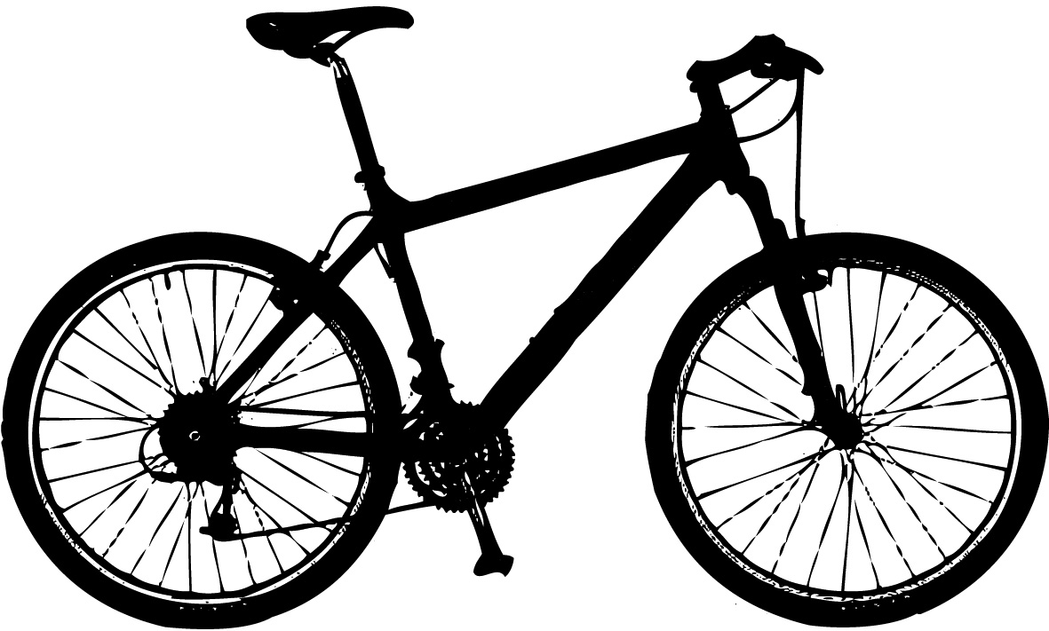

6. GEARS:
If present, do the gears change smoothly without any delays?

5. CHAIN:
Have you cleaned and oiled the chain?

---------------------------------------------------------------------------------------------------------------------------

Level 3 Course Consent Form

4. TYRES:
Are both tyres inflated to the required tyre pressure stamped on the side of the tyre?

3. BRAKES:
Does the cycle have a working front and rear brake capable of stopping the cycle?

Can your child comfortably reach and operate the brake levers?
Did you know? Many local bike shops offer free cycle checks for Bikeability participants.

For advice and videos on checking cycles, helmets, and clothing before a course, please visit our website: www.outspokentraining.co.uk/parental-information/

Full Name of Child: _________________________________________

School: ________________________________ School Year: ________

Ethnicity: ______________________________ Gender: ____________

Medical Conditions and/or Additional or Special Educational Needs:
1. MECHANICAL CONDITION:
Are the saddle, handlebars and wheel fixed on tight?

__________________________________________________________

__________________________________________________________

School Child Achieved Level 2 at: _____________________________

Are you happy for your child to be photographed and/or filmed during Bikeability training? Yes No

These images may be used by the school, Outspoken Training or The Bikeability Trust to promote the Bikeability or the organisation.

By consenting, I confirm my child:

- is medically fit to participate in Bikeability.
- has already achieved Bikeability Level 2. I understand my child won’t be allowed to progress to Level 3 if they don’t demonstrate the Bikeability Level 2 assessment criteria during the first, hour of training.
- will bring a roadworthy cycle for each session (see enclosed information). I understand that cycle training will be refused if the cycle is not roadworthy. If unsure, I will seek the advice of a professional mechanic well before Bikeability training. I understand Instructors may make minor adjustments to the cycle but will not have time to make repairs or replace parts.
- will bring and wear a helmet which conforms to British Standard EN 1078:1997 for each session.
- will have cycling and weather appropriate clothing for each session.
- may be refused cycle training if their behaviour or ability puts them or others at risk.

By consenting for my child to take part in Bikeability, I understand that pupil data will be collected and shared between my child’s school, Outspoken Training and Cambridgeshire County Council. This will be used to support the delivery and monitoring of training courses. More information on how Outspoken Training processes data can be found in their ‘Privacy Policy’ on their website.

I confirm I have read all the information enclosed in the ‘Parental Information’ and consent to my child (or the above child for whom I take responsibility) to take cycling training lessons, which may include cycle maintenance as well as riding on the public highway.

Signed: _____________________________________ parent/guardian

Date: _____________________________________________________

